**Name : Akash Arjun Sawant**

**Email ID :** [**sawantakash106@gmail.com**](mailto:sawantakash106@gmail.com)

**Day 4 Project (AWS Essentials)**

**Solution :**

1. **Linux 1 instance**

**IPv4 Public IP : 52.15.99.118**

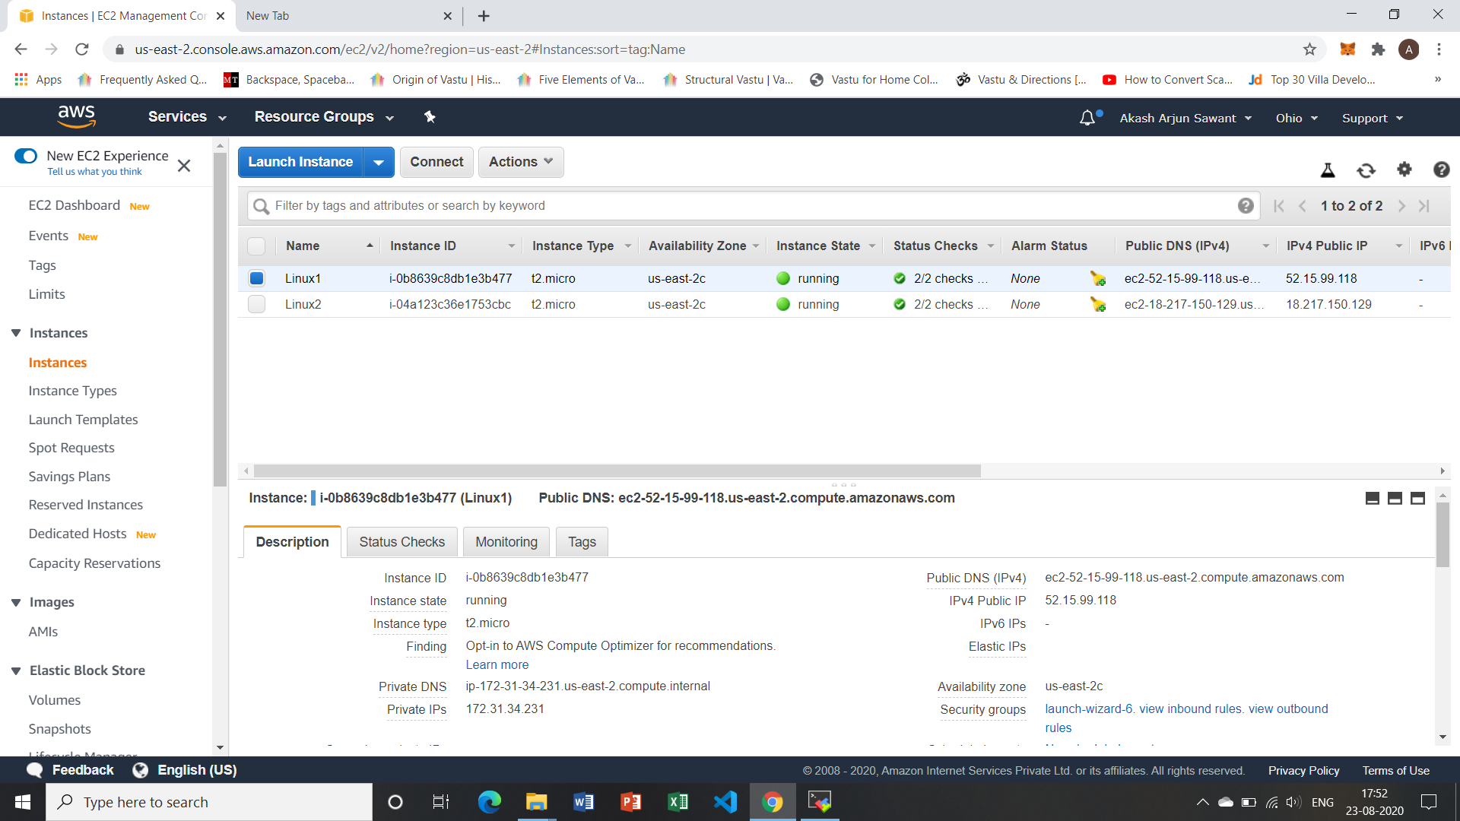

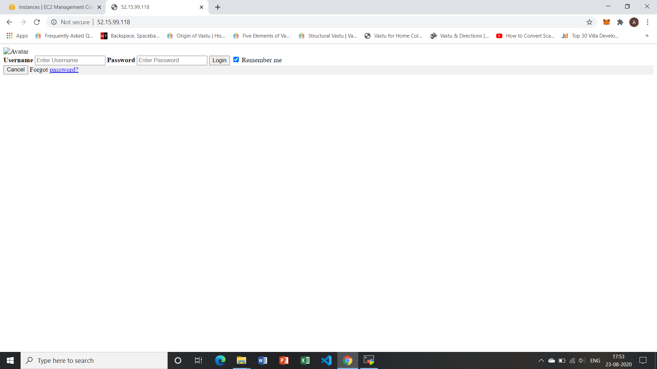

1. **Linux 2 instance**

**IPv4 Public IP : 18.217.150.129**

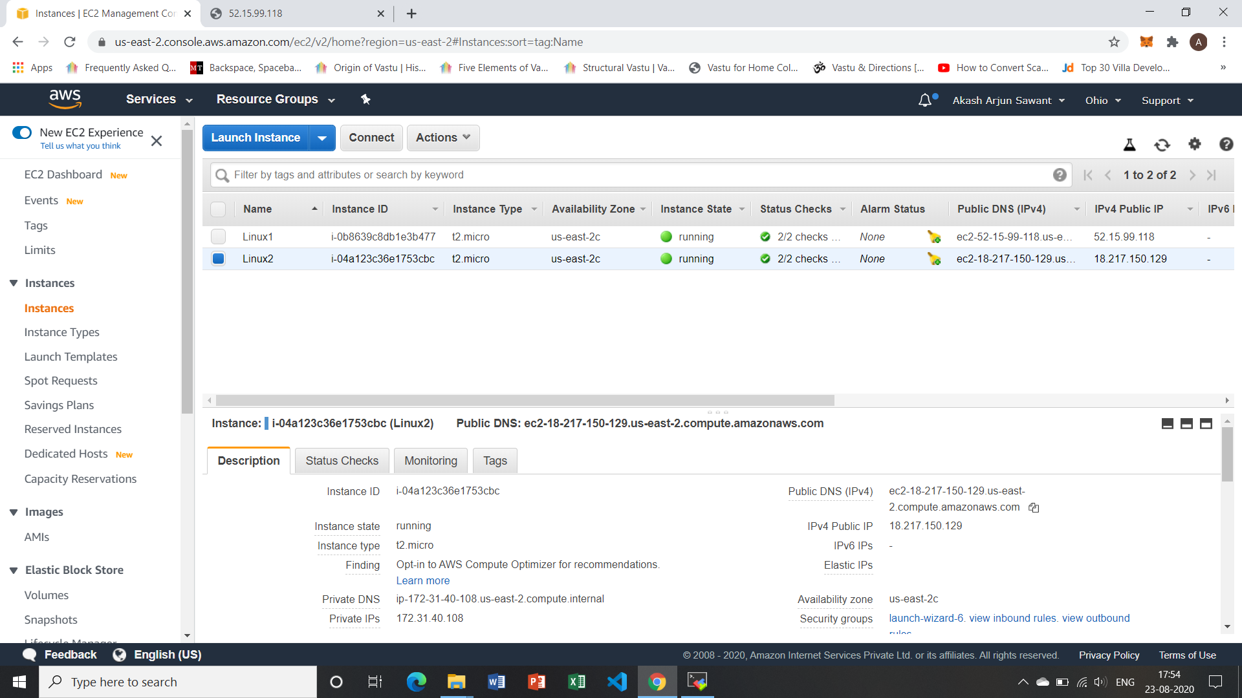

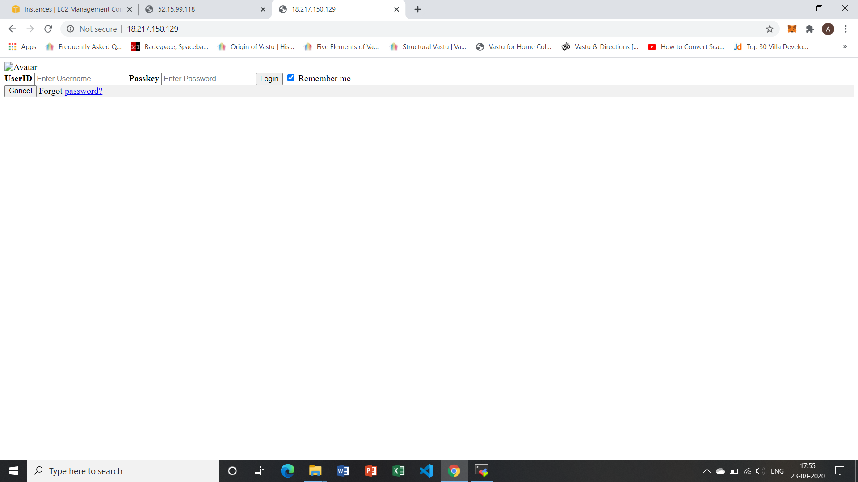

1. **ELB (Elastic Load Balancer)**

**DNS name : AkashLB1-2004699396.us-east-2.elb.amazonaws.com**

